**PIXELATE : Tasks for OpenCV**

**Q-** Use ***selectROI()*** function of openCV to select a region of a particular color in the following image and use the minimum and maximum values of the pixels in the region to threshold that color (use ***inRange()*** function).

* To read about ***selectROI()***

<https://www.learnopencv.com/how-to-select-a-bounding-box-roi-in-opencv-cpp-python/>

* To read about ***inRange()***

<https://www.learnopencv.com/tag/inrange/>

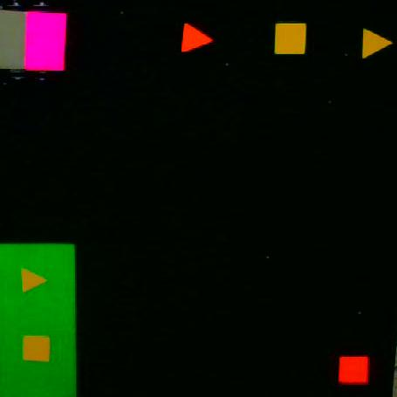

Link to Image : <https://drive.google.com/open?id=1SvYN1wSfGJ-jOdT31xTr5LziVe-j-Fa6>

For e.g. : To threshold red color, select a region of red color either from the red triangle or the red square. Use the values of the pixels to get the thresholded image. The image would look like this:

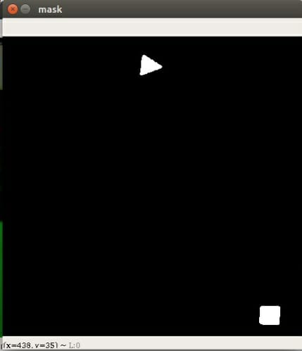

**Q-** Find the centroid of red triangle. (**OPTIONAL** : Find the centroid of yellow square present on green background ).